Thejasvenan T. 220638J
ME 2261 - Embedded Systems Log Book
Day 10 – 03.10.2025
1D Array
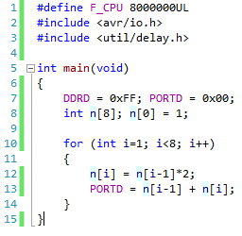
Functions
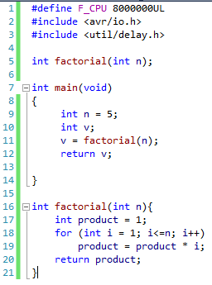

Task 1
Write program that displays the factorial of a number on an LCD, based on input from the serial monitor.
Write program that displays the factorial of a number on an PORT C, based on input from 8 bits connected to PORT D. Consider the number input in binary form.
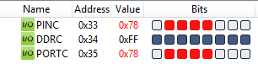
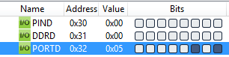
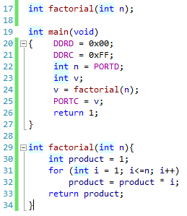
For input of PORTD = 5, output of PORTC = 120 was obtained. [5! = 120]

Pointer
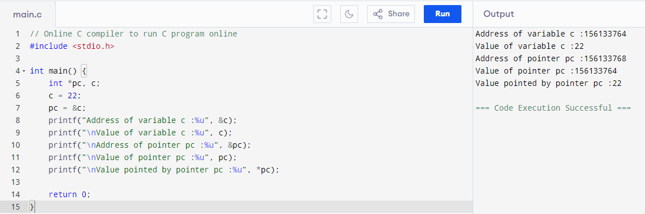
Example: -
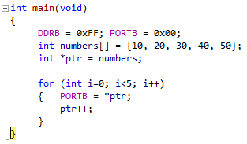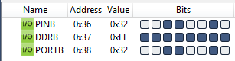

Task 2
Count number from 1 to 50 with 500 ms delay in the LCD.
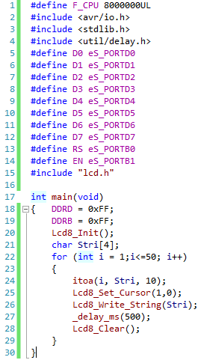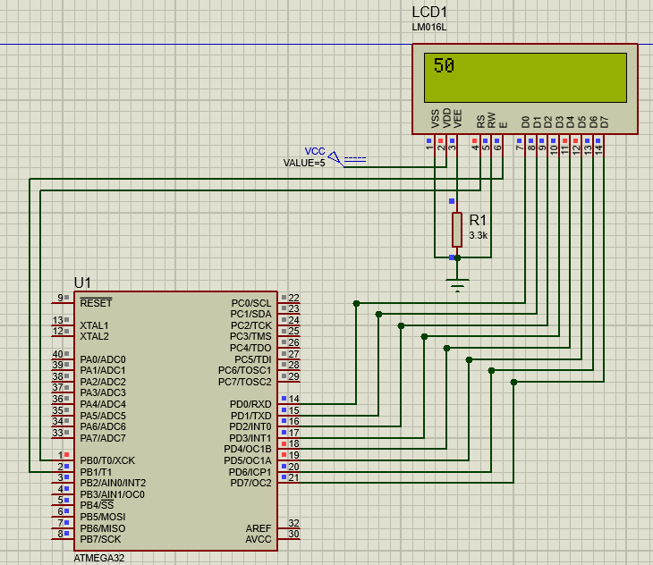
Task 3
Write a program that displays the following results.
Display ‘UOM’ and shift it to the left and then to the right.
Count down from 10 to 0 (with 1s delay)
Finally, display ‘Start LAB’ and make it blink two times.
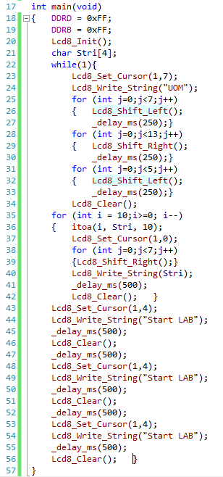

Task 1
Write program that displays the factorial of a number on an LCD, based on input from 8 switches connected to PORT A. Consider the number input in binary form using the switches.
